**Scaling policies:**

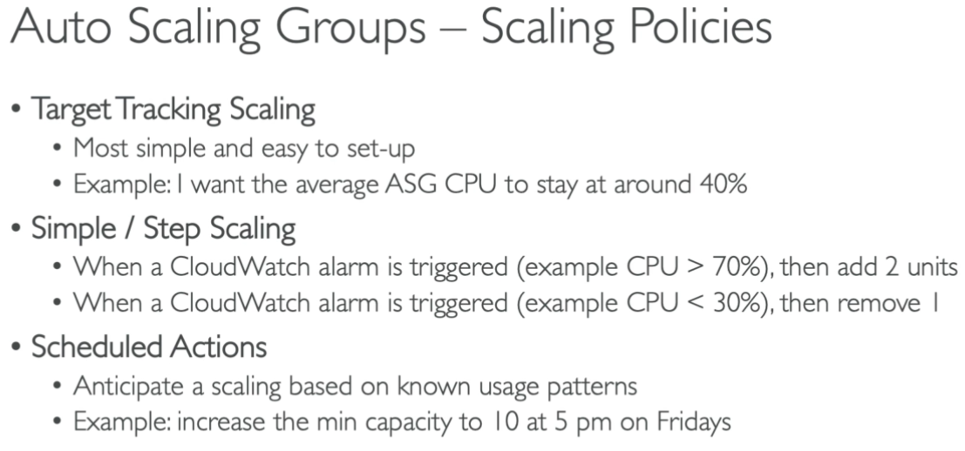

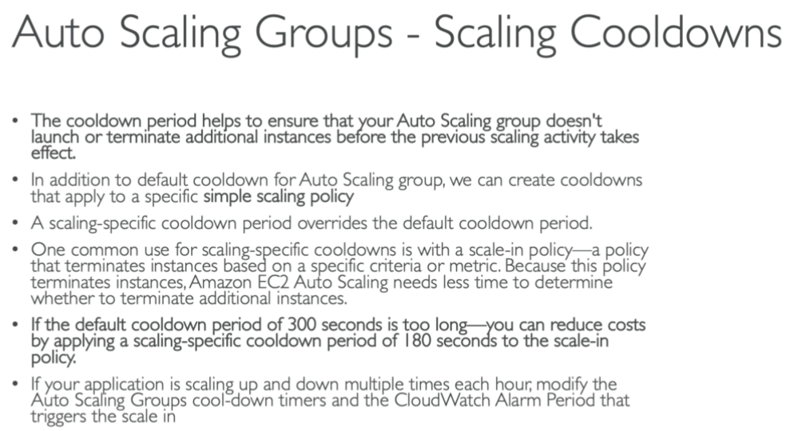

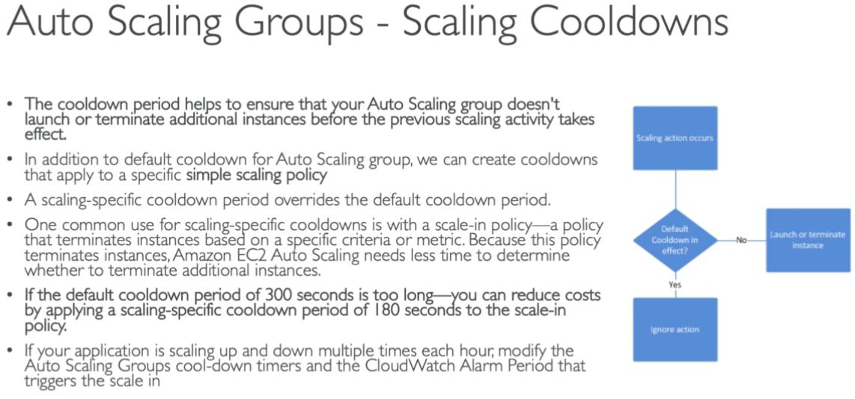

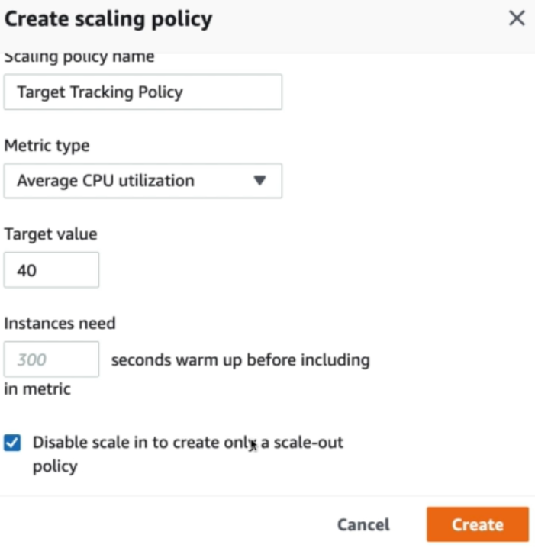

* We can add the scaling policies as above. Select the tracking policy type, give it a name, metric type and target value.
* We can select that disable option if we only want scale out option. If we want both, don’t check that option.
* As above, it takes 300 seconds time for instance to be included in metric. We can either increase or decrease it as well.
* Let’s say we set the policy to scale in the servers if the CPU is less than 20% and we make the desired state as 2.
* And if the alarm has set in CloudWatch then ASG will decrease that instance as it is not required and will set the desired state back to 1 and terminated the extra instance.

